Acts 17:1-10 — When God Plants A Church
February 18, 2024

And we also thank God constantly for this, that when you received the word of God, which you heard from us, you accepted it not as the word of men but as what it really is, the word of God, which is at work in you believers.
1 Thessalonians 2:13 (ESV)
But since we were torn away from you, brothers, for a short time, in person not in heart, we endeavored the more eagerly and with great desire to see you face to face,… 1 Thessalonians 2:17 (ESV)
- What is the history of Thessalonica?
  - A Strategic Location — Via Egnatia, Deep Natural Harbor, Fertile Soil And Rich in Minerals, and a Large Population
  - A Favored Political Status — Loyalty to Rome, Supported Marc Anthony and Octavian, Free City Status, and Emperor Worship
  - A Unique Government Structure — Citizen Assembly (demos), City Council (boule), City Leaders (politarches)
  - A Religiously Pluralistic Environment — Dionysius, Anubis, Cabirus, Aphrodite, Emperor Worship, Judaism
  - A City of Crime and Prostitution — No Windows in Houses, Organized And Accepted Brothels
- How did the gospel come to Thessalonica?
And they went through the region of Phrygia and Galatia, having been forbidden by the Holy Spirit to speak the word in Asia. And when they had come up to Mysia, they attempted to go into Bithynia, but the Spirit of Jesus did not allow them. So, passing by Mysia, they went down to Troas. And a vision appeared to Paul in the night: a man of Macedonia was standing there, urging him and saying, “Come over to Macedonia and help us.” And when Paul had seen the vision, immediately we sought to go on into Macedonia, concluding that God had called us to preach the gospel to them. Acts 16:6–10 (ESV)
Read Acts 17:1-10
Now when they had passed through Amphipolis and Apollonia, they came to Thessalonica, where there was a synagogue of the Jews. Acts 17:1 (ESV)
And Paul went in, as was his custom, and on three Sabbath days he reasoned with them from the Scriptures,… Acts 17:2 (ESV)
…explaining and proving that it was necessary for the Christ to suffer and to rise from the dead, and saying, “This Jesus, whom I proclaim to you, is the Christ.” Acts 17:3 (ESV)
  - How long was Paul in Thessalonica? — Longer than three weeks
    - The church was made up mainly of Gentiles, not Jews
For they themselves report concerning us the kind of reception we had among you, and how you turned to God from idols to serve the living and true God,…
1 Thessalonians 1:9 (ESV)
    - The Philippians sent Paul financial help two or more times.
And you Philippians yourselves know that in the beginning of the gospel, when I left Macedonia, no church entered into partnership with me in giving and receiving, except you only. Even in Thessalonica you sent me help for my needs once and again. Philippians 4:15–16 (ESV)
    - Paul had enough time to develop a business.
And some of them were persuaded and joined Paul and Silas, as did a great many of the devout Greeks and not a few of the leading women.
Acts 17:4 (ESV)
  - Who joined the new church?
    - Jews
    - Devout Greeks
    - Prominent Women
  - The Divine Passive — God changed lives and grew the church, not Paul.
Jesus said to him, “I am the way, and the truth, and the life. No one comes to the Father except through me. John 14:6 (ESV)
  - Where did Paul go when he was kicked out of the synagogue?
    - Street Corner Evangelism
So he reasoned in the synagogue with the Jews and the devout persons, and in the marketplace every day with those who happened to be there. Acts 17:17 (ESV)
    - Workshop Evangelism
For you remember, brothers, our labor and toil: we worked night and day, that we might not be a burden to any of you, while we proclaimed to you the gospel of God. 1 Thessalonians 2:9 (ESV)
…while working night and day we preached the gospel of God…
  - Opposition to Paul’s Ministry
But the Jews were jealous,… Acts 17:5a (ESV)
…and taking some wicked men of the rabble, they formed a mob, set the city in an uproar, and attacked the house of Jason, seeking to bring them out to the crowd. Acts 17:5b (ESV)
…they formed a mob, set the city in an uproar, and attacked the house of Jason, seeking to bring them out to the crowd. Acts 17:5c (ESV)
And when they could not find them, they dragged Jason and some of the brothers before the city authorities, shouting, “These men who have turned the world upside down have come here also, Acts 17:6 (ESV)
…“These men who have turned the world upside down have come here also, and Jason has received them, and they are all acting against the decrees of Caesar, saying that there is another king, Jesus.” Acts 17:6b–7 (ESV)
  - What were the charges against them?
    - Disturbing the Peace
    - Proposing a King Who Was Not Caesar
And the people and the city authorities were disturbed when they heard these things. Acts 17:8 (ESV)
  - Paul and Silas were forced to leave.
And when they had taken money as security from Jason and the rest, they let them go. Acts 17:9 (ESV)
…we wanted to come to you—I, Paul, again and again—but Satan hindered us.
1 Thessalonians 2:18 (ESV)
The brothers immediately sent Paul and Silas away by night to Berea, and when they arrived they went into the Jewish synagogue. Acts 17:10 (ESV)
  - Paul, Silas, and Timothy went to Berea.
Now these Jews were more noble than those in Thessalonica; they received the word with all eagerness, examining the Scriptures daily to see if these things were so. Many of them therefore believed, with not a few Greek women of high standing as well as men. But when the Jews from Thessalonica learned that the word of God was proclaimed by Paul at Berea also, they came there too, agitating and stirring up the crowds. Then the brothers immediately sent Paul off on his way to the sea, but Silas and Timothy remained there. Acts 17:11–14 (ESV)
  - Paul went to Athens, then Corinth.
But now that Timothy has come to us from you, and has brought us the good news of your faith and love and reported that you always remember us kindly and long to see us, as we long to see you— 1 Thessalonians 3:6 (ESV)
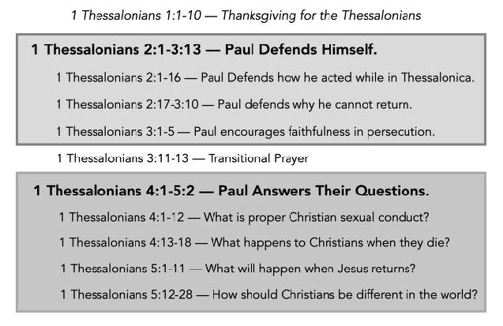
- What is the big picture of 1 Thessalonians?
Life Group Questions
- Read Acts 17:1-10. What did you learn in this message about Bible study that will help you in the future?
- Were Paul and Silas right to escape from Thessalonica? Was leaving cowardice or biblical obedience (see Luke 9:5)? If we are persecuted for our faith, when should we leave?
- Which part of the background was most helpful to you (location of the city, politics in the city, religions in the city, crime and prostitution in the city)? Why is background important?
- Read Acts 17:4. This verse highlights that God changed hearts and grew the church, not Paul. Why is this important? Regarding sharing the gospel, what is our role? What is God’s?
- God grew a great church in a rough place called Thessalonica. How does knowing that God does some of his best work in our lives in the most challenging circumstances encourage you?

