1 Thessalonians 1:1-10 — How Can I Recognize Genuine Faith?
March 3, 2024

- Background

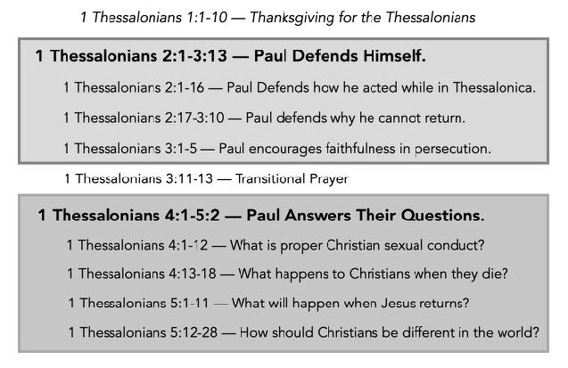

Paul, Silvanus, and Timothy, To the church of the Thessalonians in God the Father and the Lord Jesus Christ: Grace to you and peace.
1 Thessalonians 1:1 (ESV)

For we know, brothers loved by God, that he has chosen you,…
1 Thessalonians 1:4 (ESV)

- Ten Questions to Recognize Genuine Faith
We give thanks to God always for all of you, constantly mentioning you in our prayers, remembering before our God and Father your work of faith and labor of love and steadfastness of hope in our Lord Jesus Christ.
1 Thessalonians 1:2-3 (ESV)

  - Do I have faith that shows itself in what I do?
For by grace you have been saved through faith. And this is not your own doing; it is the gift of God, not a result of works, so that no one may boast. Ephesians 2:8–9 (ESV)

For by works of the law no human being will be justified in his sight, since through the law comes knowledge of sin. Romans 3:20 (ESV)

Therefore, since we have been justified by faith, we have peace with God through our Lord Jesus Christ. Romans 5:1 (ESV)

For we are his workmanship, created in Christ Jesus for good works, which God prepared beforehand, that we should walk in them. Ephesians 2:10 (ESV)

So also faith by itself, if it does not have works, is dead. But someone will say, “You have faith and I have works.” Show me your faith apart from your works, and I will show you my faith by my works. James 2:17-18 (ESV)

For as the body apart from the spirit is dead, so also faith apart from works is dead. James 2:26 (ESV)

  - Do I have faith that shows itself in what I love?
For the love of Christ controls us, because we have concluded this: that one has died for all, therefore all have died; 2 Corinthians 5:14 (ESV)

  - Do I have faith that perseveres under pressure?
…training us to renounce ungodliness and worldly passions, and to live self-controlled, upright, and godly lives in the present age, waiting for our blessed hope, the appearing of the glory of our great God and Savior Jesus Christ, Titus 2:12–13 (ESV)

Through him we have also obtained access by faith into this grace in which we stand, and we rejoice in hope of the glory of God. Romans 5:2 (ESV)

They went out from us, but they were not of us; for if they had been of us, they would have continued with us. But they went out, that it might become plain that they all are not of us. 1 John 2:19 (ESV)

But the one who endures to the end will be saved. Matthew 24:13 (ESV)
…strengthening the souls of the disciples, encouraging them to continue in the faith, and saying that through many tribulations we must enter the kingdom of God.
Acts 14:22 (ESV)

  - Does the Word of God strike me with power and conviction?
…because our gospel came to you not only in word, but also in power and in the Holy Spirit and with full conviction… 1 Thessalonians 1:5a (ESV)

So faith comes from hearing, and hearing through the word of Christ.
Romans 10:17 (ESV)
since you have been born again, not of perishable seed but of imperishable, through the living and abiding word of God; 1 Peter 1:23 (ESV)

And you were dead in the trespasses and sins in which you once walked, following the course of this world, following the prince of the power of the air, the spirit that is now at work in the sons of disobedience— Ephesians 2:1–2 (ESV)

  - Do I have a new life?
And you became imitators of us and of the Lord,.. 1 Thessalonians 1:6a (ESV)

We were buried therefore with him by baptism into death, in order that, just as Christ was raised from the dead by the glory of the Father, we too might walk in newness of life. Romans 6:4 (ESV)

Therefore, if anyone is in Christ, he is a new creation. The old has passed away; behold, the new has come. 2 Corinthians 5:17 (ESV)

  - Do I have joy that transcends my circumstances?
…for you received the word in much affliction, with the joy of the Holy Spirit,…
1 Thessalonians 1:6b (ESV)

For you, brothers, became imitators of the churches of God in Christ Jesus that are in Judea. For you suffered the same things from your own countrymen as they did from the Jews, 1 Thessalonians 2:14 (ESV)

For when we were with you, we kept telling you beforehand that we were to suffer affliction, just as it has come to pass, and just as you know. 1 Thessalonians 3:4 (ESV)

  - Is my faith worthy of being followed?
…so that you became an example to all the believers in Macedonia and in Achaia.
1 Thessalonians 1:7 (ESV)

  - Am I a bold witness?
For not only has the word of the Lord sounded forth from you in Macedonia and Achaia, but your faith in God has gone forth everywhere, so that we need not say anything.
1 Thessalonians 1:8 (ESV)

  - Have I left my old life behind?
…and how you turned to God from idols to serve the living and true God,
1 Thessalonians 1:9b (ESV)

  - Am I looking forward to Jesus’ return?
…and to wait for his Son from heaven, whom he raised from the dead, Jesus who delivers us from the wrath to come. 1 Thessalonians 1:10 (ESV)

Life Group Questions
- How would your family and friends describe your faith? What evidence would they cite for proof that your faith is authentic?
- Read Ephesians 2:8-10, James 2:17-18. What are the works in a Christian’s life that would be evidence for genuine faith in their life? Feel free to let members of your life group tell you what evidence they see in your life if you are unsure you have any.
- Read 1 Thessalonians 1:3 and 2 Corinthians 5:14. How does what we love reveal what is important to us? If we love Jesus, how does that change our daily choices?
- Read 1 Thessalonians 1:5a, 1 Peter 1:23. For those with genuine faith, the Bible strikes them with power and conviction when it is preached or read. Share a time when you read the Bible or heard it taught, and it struck you with power and conviction.
- Read 1 Thessalonians 1:6b and 2 Corinthians 8:2. How can a Christian have joy in hard times? Have you experienced this?
- Read 1 Thessalonians 1:9b, Ephesians 4:22-24. Have you found yourself living with one foot in a world and with the other foot following Jesus? What is the danger of being lukewarm for Jesus? See Revelation 3:14-22.
- What is the difference between spiritually backsliding and fake faith?

