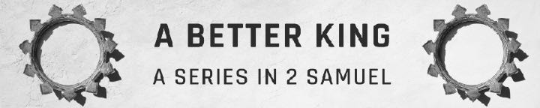
2 Samuel 21 — Sin’s Consequences And Teamwork
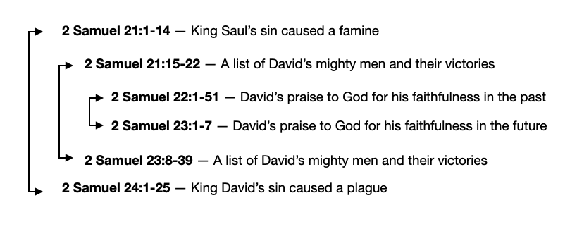
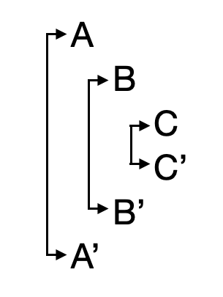
January 14, 2024

- King Saul’s sin led to famine and death.
Now there was a famine in the days of David for three years, year after year…
2 Samuel 21:1a (ESV)
“And if you faithfully obey the voice of the LORD your God, being careful to do all his commandments that I command you today, the LORD your God will set you high above all the nations of the earth…. blessed shall you be in the field. Blessed shall be the fruit of your womb and the fruit of your ground and the fruit of your cattle, the increase of your herds and the young of your flock…. Deuteronomy 28:1–6 (ESV)
“But if you will not obey the voice of the LORD your God or be careful to do all his commandments and his statutes that I command you today, then all these curses shall come upon you and overtake you… cursed shall you be in the field. Cursed shall be your basket and your kneading bowl. Cursed shall be the fruit of your womb and the fruit of your ground, the increase of your herds and the young of your flock….
Deuteronomy 28:15–19 (ESV)
…and the heavens over your head shall be bronze, and the earth under you shall be iron. The LORD will make the rain of your land powder. From heaven dust shall come down on you until you are destroyed. Deuteronomy 28:23–24 (ESV)
…and the LORD said, “There is bloodguilt on Saul and on his house, because he put the Gibeonites to death.” 2 Samuel 21:1b (ESV)
So the king called the Gibeonites and spoke to them… 2 Samuel 21:2a (ESV)
…Now the Gibeonites were not of the people of Israel but of the remnant of the Amorites. Although the people of Israel had sworn to spare them, Saul had sought to strike them down in his zeal for the people of Israel and Judah.
2 Samuel 21:2b (ESV)
And David said to the Gibeonites, “What shall I do for you? And how shall I make atonement, that you may bless the heritage of the LORD?”
2 Samuel 21:3 (ESV)
The Gibeonites said to him, “It is not a matter of silver or gold between us and Saul or his house; neither is it for us to put any man to death in Israel.”…
2 Samuel 21:4a (ESV)
Moreover, you shall accept no ransom for the life of a murderer, who is guilty of death, but he shall be put to death. Numbers 35:31 (ESV)
…And he said, “What do you say that I shall do for you?”
2 Samuel 21:4b (ESV)
They said to the king, “The man who consumed us and planned to destroy us, so that we should have no place in all the territory of Israel, let seven of his sons be given to us, so that we may hang them before the LORD at Gibeah of Saul, the chosen of the LORD.” And the king said, “I will give them.”
2 Samuel 21:5–6 (ESV)
You shall not pollute the land in which you live, for blood pollutes the land, and no atonement can be made for the land for the blood that is shed in it, except by the blood of the one who shed it. Numbers 35:33 (ESV)
But the king spared Mephibosheth, the son of Saul’s son Jonathan, because of the oath of the LORD that was between them, between David and Jonathan the son of Saul. 2 Samuel 21:7 (ESV)
The king took the two sons of Rizpah the daughter of Aiah, whom she bore to Saul, Armoni and Mephibosheth; and the five sons of Merab the daughter of Saul, whom she bore to Adriel the son of Barzillai the Meholathite; and he gave them into the hands of the Gibeonites, and they hanged them on the mountain before the LORD, and the seven of them perished together. They were put to death in the first days of harvest, at the beginning of barley harvest. 2 Samuel 21:8–9 (ESV)
Then Rizpah the daughter of Aiah took sackcloth and spread it for herself on the rock, from the beginning of harvest until rain fell upon them from the heavens. And she did not allow the birds of the air to come upon them by day, or the beasts of the field by night. 2 Samuel 21:10 (ESV)
When David was told what Rizpah the daughter of Aiah, the concubine of Saul, had done, David went and took the bones of Saul and the bones of his son Jonathan from the men of Jabesh-gilead, who had stolen them from the public square of Beth-shan, where the Philistines had hanged them, on the day the Philistines killed Saul on Gilboa. And he brought up from there the bones of Saul and the bones of his son Jonathan; and they gathered the bones of those who were hanged. And they buried the bones of Saul and his son Jonathan in the land of Benjamin in Zela, in the tomb of Kish his father. And they did all that the king commanded. And after that God responded to the plea for the land. 2 Samuel 21:11–14 (ESV)
What can we learn?
  - Saul, not David, was responsible for the death of King Saul’s sons and grandsons.
The LORD has avenged on you all the blood of the house of Saul,…See, your evil is on you, for you are a man of blood.” 2 Samuel 16:8 (ESV)
  - Sin brings suffering to many more than ourselves.
    - Saul’s sons died as a result of his sin with the Gibeonites.
    - Four of David’s sons died from his murder of Uriah (Bathsheba’s infant son, Amnon, Absalom, and Adonijah)
  - The sins of a leader bring great suffering to the people.
  - God is sovereign over natural disasters.
I form light and create darkness; I make well-being and create calamity; I am the Lord, who does all these things. Isaiah 45:7 (ESV)
  - God remembers the promises we make before Him.

- David needed a team.
A. The Death Of Ishbi-benob
There was war again between the Philistines and Israel, and David went down together with his servants, and they fought against the Philistines. And David grew weary. 2 Samuel 21:15 (ESV)
And Ishbi-benob, one of the descendants of the giants, whose spear weighed three hundred shekels of bronze, and who was armed with a new sword, thought to kill David. 2 Samuel 21:16 (ESV)
But Abishai the son of Zeruiah came to his aid and attacked the Philistine and killed him. Then David’s men swore to him, “You shall no longer go out with us to battle, lest you quench the lamp of Israel.” 2 Samuel 21:17 (ESV)
B. The Death Of Saph
After this there was again war with the Philistines at Gob. Then Sibbecai the Hushathite struck down Saph, who was one of the descendants of the giants.
2 Samuel 21:18 (ESV)
C. The Death Of Lahmi, Goliath’s Brother
And there was again war with the Philistines at Gob, and Elhanan the son of Jaare-oregim, the Bethlehemite, struck down Goliath the Gittite, the shaft of whose spear was like a weaver’s beam. 2 Samuel 21:19 (ESV)
And there was again war with the Philistines, and Elhanan the son of Jair struck down Lahmi the brother of Goliath the Gittite, the shaft of whose spear was like a weaver’s beam.
1 Chronicles 20:5 (ESV)
D. The Death Of Six-Fingers
And there was again war at Gath, where there was a man of great stature, who had six fingers on each hand, and six toes on each foot, twenty-four in number, and he also was descended from the giants. And when he taunted Israel, Jonathan the son of Shimei, David’s brother, struck him down.
2 Samuel 21:20–21 (ESV)
These four were descended from the giants in Gath, and they fell by the hand of David and by the hand of his servants. 2 Samuel 21:22 (ESV)
What can we learn?
- David didn’t work alone. He needed a faithful team to accomplish the work God gave him to do. In the church, we are no different.
- Jesus died as our substitute in our place to take away the eternal consequences of our sins.
Life Group Questions
- Read 2 Samuel 21.
- What actions have you seen in leaders that brought great harm to the organization or nation they were leading?
- How do you feel about King Saul’s sons and grandsons dying for his attempt to genocide the Gibeonites?
- Both King Saul and King David had children who died because of their father’s sins. How would you answer someone who said God was unjust in punishing Saul’s children for what he did?
- Read Deuteronomy 24:16 and Exodus 20:5. How would you reconcile these seemingly contradictory passages? Do they apply to the death of Saul’s children in this chapter? If not, why not?
- What does 2 Samuel 21:1-14 teach about keeping promises? Should we keep our promises no matter how long ago they were made or how costly they are to fulfill?
- God surrounded David with faithful Godly men to help him accomplish the work God gave him to do. What does this teach us about the importance of Christians being part of a church and serving in the church for us to accomplish God’s will for our lives?

