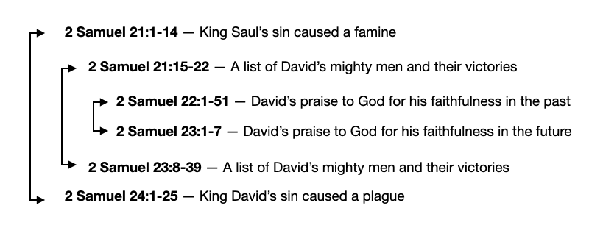
2 Samuel 22 — Speaking Of God’s Goodness
January 21, 2024

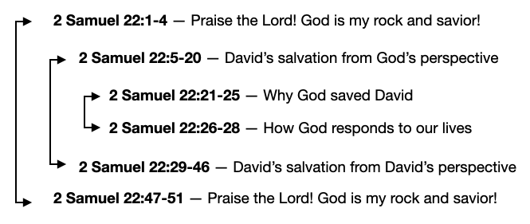

And David spoke to the LORD the words of this song on the day when the LORD delivered him from the hand of all his enemies, and from the hand of Saul. 2 Samuel 22:1 (ESV)
- 2 Samuel 22:1-4 — Praise the Lord! God is my rock and savior!
He said, “The Lord is my rock and my fortress and my deliverer, my God, my rock, in whom I take refuge, my shield, and the horn of my salvation, my stronghold and my refuge, my savior; you save me from violence.”
2 Samuel 22:2–3 (ESV)
I call upon the LORD, who is worthy to be praised, and I am saved from my enemies. 2 Samuel 22:4 (ESV)
- 2 Samuel 22:5-20 — David’s salvation from God’s perspective.
For the waves of death encompassed me, the torrents of destruction assailed me; the cords of Sheol entangled me; the snares of death confronted me. In my distress I called upon the LORD; to my God I called. From his temple he heard my voice, and my cry came to his ears. 2 Samuel 22:5–7 (ESV)
…there is but a step between me and death. 1 Samuel 20:3b (ESV)
Then David said in his heart, “Now I shall perish one day by the hand of Saul.”
1 Samuel 27:1a (ESV)
Then the earth reeled and rocked; the foundations of the heavens trembled and quaked, because he was angry. Smoke went up from his nostrils, and devouring fire from his mouth; glowing coals flamed forth from him.
2 Samuel 22:8–9 (ESV)
He bowed the heavens and came down; thick darkness was under his feet. He rode on a cherub and flew; he was seen on the wings of the wind.
2 Samuel 22:10–11 (ESV)
He made darkness around him his canopy, thick clouds, a gathering of water. Out of the brightness before him coals of fire flamed forth.
2 Samuel 22:12–13 (ESV)
The LORD thundered from heaven, and the Most High uttered his voice. And he sent out arrows and scattered them; lightning, and routed them.
2 Samuel 22:14–15 (ESV)
Then the channels of the sea were seen; the foundations of the world were laid bare, at the rebuke of the LORD, at the blast of the breath of his nostrils.
2 Samuel 22:16 (ESV)
He sent from on high, he took me; he drew me out of many waters. He rescued me from my strong enemy, from those who hated me, for they were too mighty for me. They confronted me in the day of my calamity, but the LORD was my support. He brought me out into a broad place; he rescued me, because he delighted in me. 2 Samuel 22:17–20 (ESV)
…bring them up out of that land to a good and broad land, a land flowing with milk and honey, to the place of the Canaanites, the Hittites, the Amorites, the Perizzites, the Hivites, and the Jebusites. Exodus 3:8 (ESV)
- 2 Samuel 22:21-25 — Why did God save David?
  - God rescued David because God delighted in him.
He brought me out into a broad place; he rescued me, because he delighted in me. 2 Samuel 22:20 (ESV)
…even as he chose us in him before the foundation of the world, that we should be holy and blameless before him… Ephesians 1:4 (ESV)
  - God rewarded David for his righteousness.
The LORD dealt with me according to my righteousness; according to the cleanness of my hands he rewarded me. For I have kept the ways of the LORD and have not wickedly departed from my God. For all his rules were before me, and from his statutes I did not turn aside. I was blameless before him, and I kept myself from guilt. And the LORD has rewarded me according to my righteousness, according to my cleanness in his sight. 2 Samuel 22:21–25 (ESV)
…because David did what was right in the eyes of the LORD and did not turn aside from anything that he commanded him all the days of his life, except in the matter of Uriah the Hittite. 1 Kings 15:5 (ESV)
For the eyes of the Lord are on the righteous, and his ears are open to their prayer. But the face of the Lord is against those who do evil. 1 Peter 3:12 (ESV)
The LORD rewards every man for his righteousness and his faithfulness,…
1 Samuel 26:23 (ESV)
- 2 Samuel 22:26-28 — How does God respond to our lives?
With the merciful you show yourself merciful; with the blameless man you show yourself blameless; with the purified you deal purely, and with the crooked you make yourself seem tortuous. You save a humble people, but your eyes are on the haughty to bring them down. 2 Samuel 22:26–28 (ESV)
…give, and it will be given to you. Good measure, pressed down, shaken together, running over, will be put into your lap. For with the measure you use it will be measured back to you. Luke 6:38 (ESV)
- 2 Samuel 22:29-46 — David’s salvation from David’s perspective
For you are my lamp, O Lord, and my God lightens my darkness. For by you I can run against a troop, and by my God I can leap over a wall. This God—his way is perfect; the word of the Lord proves true; he is a shield for all those who take refuge in him. 2 Samuel 22:29–31 (ESV)
For who is God, but the LORD? And who is a rock, except our God? This God is my strong refuge and has made my way blameless. He made my feet like the feet of a deer and set me secure on the heights. He trains my hands for war, so that my arms can bend a bow of bronze. You have given me the shield of your salvation, and your gentleness made me great. You gave a wide place for my steps under me, and my feet did not slip; 2 Samuel 22:32–37 (ESV)
I pursued my enemies and destroyed them, and did not turn back until they were consumed. I consumed them; I thrust them through, so that they did not rise; they fell under my feet. For you equipped me with strength for the battle; you made those who rise against me sink under me. You made my enemies turn their backs to me, those who hated me, and I destroyed them. They looked, but there was none to save; they cried to the LORD, but he did not answer them. I beat them fine as the dust of the earth; I crushed them and stamped them down like the mire of the streets. 2 Samuel 22:38–43 (ESV)
You delivered me from strife with my people; you kept me as the head of the nations; people whom I had not known served me. Foreigners came cringing to me; as soon as they heard of me, they obeyed me. Foreigners lost heart and came trembling out of their fortresses. 2 Samuel 22:44–46 (ESV)
- 2 Samuel 22:47-51 — Praise the Lord! God is my rock and savior!
The Lord lives, and blessed be my rock, and exalted be my God, the rock of my salvation, the God who gave me vengeance and brought down peoples under me, who brought me out from my enemies; you exalted me above those who rose against me; you delivered me from men of violence. “For this I will praise you, O Lord, among the nations, and sing praises to your name.”
2 Samuel 22:47–50 (ESV)
For I tell you that Christ became a servant to the circumcised to show God’s truthfulness, in order to confirm the promises given to the patriarchs, and in order that the Gentiles might glorify God for his mercy. As it is written, “Therefore I will praise you among the Gentiles, and sing to your name.” Romans 15:8–9 (ESV)
Great salvation he brings to his king, and shows steadfast love to his anointed, to David and his offspring forever. 2 Samuel 22:51 (ESV)

What can we learn?
- God is our rock, my savior, and my protector. If God saved David when he called on him in desperate need, as God’s chosen people, we can be confident God will respond when we call on Him in our time of desperate need.
- The holiness of our lives impacts how God responds to our lives and our prayers. God honors those who honor him.
- As David couldn’t help but tell the nations about the goodness of God in his life, we should be overflowing with the message of God’s goodness in our lives through Jesus.

Life Group Questions
- Read 2 Samuel 22. After reading how God rescued David in his time of need, how had God rescued you? How does this chapter change the way you will pray in a crisis?
- Read 2 Samuel 22:21-25. While we cannot over-emphasize the righteousness God gives us through Christ, do you think we under-emphasize the importance of holy living?
- If God rewards us according to our righteousness, what do those rewards look like?
- If it was the Lord who gave David his victories, why did he have to fight so hard? What does that teach us?
- Read 2 Samuel 22:50. David wanted his song to be sung among the nations so they would come to know the goodness of God. What goodness has God shown to me through Jesus? How can I talk about it in public more?
- What about this chapter points forward to Jesus? Read 2 Samuel 7:12, 16, Romans 15:8-9.

