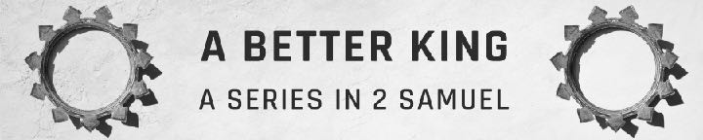
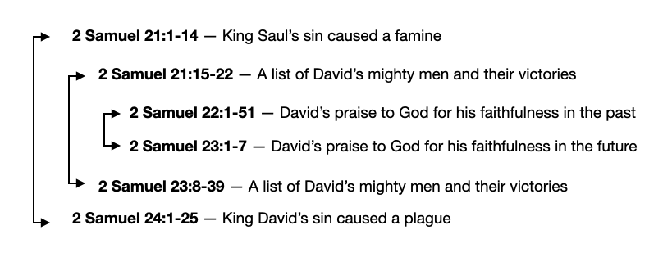
2 Samuel 23 — Successful Leaders And Their Team
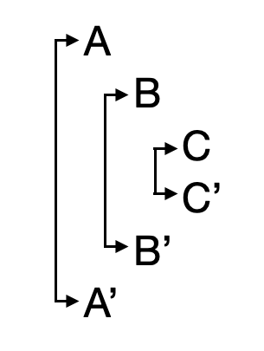
January 28, 2024

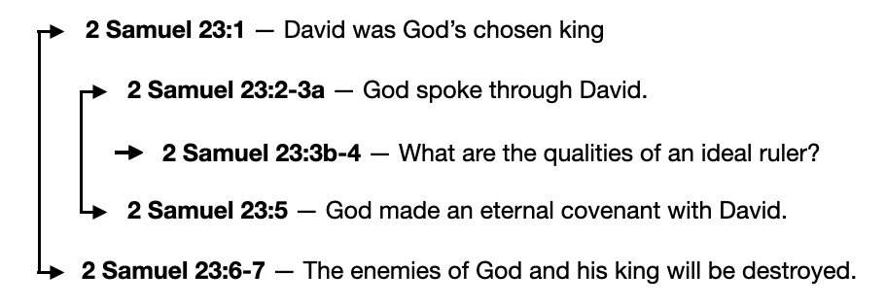

- What does it take to be a successful leader?
Now these are the last words of David… 2 Samuel 23:1a (ESV)
  - 2 Samuel 23:1 — David was God’s chosen king.
…The oracle of David, the son of Jesse,… 2 Samuel 23:1b (ESV)
…the oracle of the man who was raised on high,… 2 Samuel 23:1b (ESV)
And David became greater and greater, for the LORD, the God of hosts, was with him.
2 Samuel 5:10 (ESV)
But you are a chosen race, a royal priesthood, a holy nation, a people for his own possession, that you may proclaim the excellencies of him who called you out of darkness into his marvelous light. 1 Peter 2:9 (ESV)
…the anointed of the God of Jacob,… 2 Samuel 23:1d (ESV)
…the sweet psalmist of Israel: 2 Samuel 23:1e (ESV)
  - 2 Samuel 23:2-3a — God spoke through David.
The Spirit of the LORD speaks by me; his word is on my tongue.
2 Samuel 23:2 (ESV)
All Scripture is breathed out by God and profitable for teaching, for reproof, for correction, and for training in righteousness, 2 Timothy 3:16 (ESV)
For no prophecy was ever produced by the will of man, but men spoke from God as they were carried along by the Holy Spirit. 2 Peter 1:21 (ESV)
The God of Israel has spoken; the Rock of Israel has said to me…
2 Samuel 23:3a (ESV)
  - 2 Samuel 23:3b-4 — What are the qualities of an ideal ruler?
…When one rules justly over men, ruling in the fear of God,
2 Samuel 23:3b (ESV)
1. Leading Justly
2. Leading With Fear Of God.
…he dawns on them like the morning light, like the sun shining forth on a cloudless morning, like rain that makes grass to sprout from the earth.
2 Samuel 23:4 (ESV)
  - 2 Samuel 23:5 — God made an eternal covenant with David.
For does not my house stand so with God? For he has made with me an everlasting covenant, ordered in all things and secure. For will he not cause to prosper all my help and my desire? 2 Samuel 23:5 (ESV)
When your days are fulfilled and you lie down with your fathers, I will raise up your offspring after you, who shall come from your body, and I will establish his kingdom… but my steadfast love will not depart from him, as I took it from Saul, whom I put away from before you. And your house and your kingdom shall be made sure forever before me. Your throne shall be established forever.’ ” 2 Samuel 7:12, 15–16 (ESV)
  - 2 Samuel 23:6-7 — The enemies of God and his king will be destroyed.
But worthless men are all like thorns that are thrown away, for they cannot be taken with the hand; but the man who touches them arms himself with iron and the shaft of a spear, and they are utterly consumed with fire.”
2 Samuel 23:6–7 (ESV)
- When God raises up a leader, he raises up a team.
  - 2 Samuel 23:8-12 — David’s most famous soldiers, The Three
These are the names of the mighty men whom David had:…
2 Samuel 23:8a (ESV)
Josheb-baashebath
…Josheb-basshebeth a Tahchemonite; he was chief of the three. He wielded his spear against eight hundred whom he killed at one time.
2 Samuel 23:8b (ESV)
Eleazar
And next to him among the three mighty men was Eleazar the son of Dodo, son of Ahohi. He was with David when they defied the Philistines who were gathered there for battle, and the men of Israel withdrew. He rose and struck down the Philistines until his hand was weary, and his hand clung to the sword. And the LORD brought about a great victory that day, and the men returned after him only to strip the slain. 2 Samuel 23:9–10 (ESV)
Shammah
And next to him was Shammah, the son of Agee the Hararite. The Philistines gathered together at Lehi, where there was a plot of ground full of lentils, and the men fled from the Philistines. But he took his stand in the midst of the plot and defended it and struck down the Philistines, and the LORD worked a great victory. 2 Samuel 23:11–12 (ESV)
  - 2 Samuel 23:13-17 — Loyalty And Love From Water In Bethlehem
And three of the thirty chief men went down and came about harvest time to David at the cave of Adullam, when a band of Philistines was encamped in the Valley of Rephaim. 2 Samuel 23:13 (ESV)
David was then in the stronghold, and the garrison of the Philistines was then at Bethlehem. And David said longingly, “Oh, that someone would give me water to drink from the well of Bethlehem that is by the gate!”
2 Samuel 23:14-15 (ESV)
Then the three mighty men broke through the camp of the Philistines and drew water out of the well of Bethlehem that was by the gate and carried and brought it to David…. 2 Samuel 23:16a (ESV)
…But he would not drink of it. He poured it out to the LORD and said, “Far be it from me, O LORD, that I should do this. Shall I drink the blood of the men who went at the risk of their lives?” Therefore he would not drink it. These things the three mighty men did. 2 Samuel 23:16b-17 (ESV)
  - 2 Samuel 23:18-23 — Two Notable Heroes
Abishai
Now Abishai, the brother of Joab, the son of Zeruiah, was chief of the thirty. And he wielded his spear against three hundred men and killed them and won a name beside the three. He was the most renowned of the thirty and became their commander, but he did not attain to the three. 2 Samuel 23:18–19 (ESV)
Benaiah
And Benaiah the son of Jehoiada was a valiant man of Kabzeel, a doer of great deeds. He struck down two ariels of Moab. He also went down and struck down a lion in a pit on a day when snow had fallen. And he struck down an Egyptian, a handsome man. The Egyptian had a spear in his hand, but Benaiah went down to him with a staff and snatched the spear out of the Egyptian’s hand and killed him with his own spear. These things did Benaiah the son of Jehoiada, and won a name beside the three mighty men. He was renowned among the thirty, but he did not attain to the three. And David set him over his bodyguard. 2 Samuel 23:20–23 (ESV)
  - 2 Samuel 23:24-39 — The Thirty
Asahel the brother of Joab was one of the thirty; Elhanan the son of Dodo of Bethlehem, Shammah of Harod, Elika of Harod, Helez the Paltite, Ira the son of Ikkesh of Tekoa, Abiezer of Anathoth, Mebunnai the Hushathite, Zalmon the Ahohite, Maharai of Netophah, Heleb the son of Baanah of Netophah, Ittai the son of Ribai of Gibeah of the people of Benjamin, Benaiah of Pirathon, Hiddai of the brooks of Gaash, Abi-albon the Arbathite, Azmaveth of Bahurim, Eliahba the Shaalbonite, the sons of Jashen, Jonathan, Shammah the Hararite, Ahiam the son of Sharar the Hararite, Eliphelet the son of Ahasbai of Maacah, Eliam the son of Ahithophel the Gilonite, Hezro of Carmel, Paarai the Arbite, Igal the son of Nathan of Zobah, Bani the Gadite, Zelek the Ammonite, Naharai of Beeroth, the armor-bearer of Joab the son of Zeruiah, Ira the Ithrite, Gareb the Ithrite, Uriah the Hittite: thirty-seven in all. 2 Samuel 23:24–39 (ESV)
What can we learn?
- A good leader focuses on justice for people and accountability before God.
- God promised to establish an eternal kingdom through David’s family line. The descendant of David, who established the everlasting kingdom, was Jesus. He is the leader worth following, the leader we can trust.
- When God raises a leader, he raises a team of courageous and godly people around them. God usually works through a team.
- The success of David and his men did not come from natural strength but from God as they courageously prayed and risked their lives for Him.
Life Group Questions
- Read 2 Samuel 23. What was important to you in this chapter?
- Read 2 Samuel 23:1-2. Why did David stress that his words were God’s words, not his own opinion? Why was that important?
- Read 2 Samuel 23:3-4. What does David say are the qualities and results of a godly leadership? Describe a time when you have seen bad leadership that lead to terrible results. Why is it easy for a leader to become corrupt?
- Read 2 Samuel 23:5. Why was David not concerned about the future of his dynasty?
Read 2 Samuel 7:12, 15-16. Why must God’s promise of an eternal dynasty point to Jesus?
- Read 2 Samuel 23:8-12. Why did God give David a team of mighty men? What was the key to their success?

