Heterosexuality

- Why did God make us sexual?

Now as the church submits to Christ, so also wives should submit in everything to their husbands. Husbands, love your wives, as Christ loved the church and gave himself up for her, that he might sanctify her, having cleansed her by the washing of water with the word, so that he might present the church to himself in splendor, without spot or wrinkle or any such thing, that she might be holy and without blemish. In the same way husbands should love their wives as their own bodies. He who loves his wife loves himself. For no one ever hated his own flesh, but nourishes and cherishes it, just as Christ does the church, because we are members of his body. “Therefore a man shall leave his father and mother and hold fast to his wife, and the two shall become one flesh.” This mystery is profound, and I am saying that it refers to Christ and the church. Ephesians 5:24–32 (ESV)

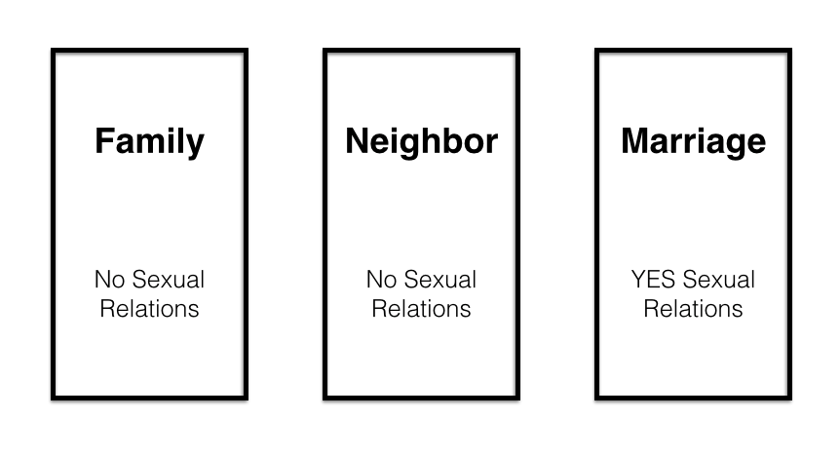
Or do you not know that he who is joined to a prostitute becomes one body with her? For, as it is written, “The two will become one flesh.” 1 Corinthians 6:16 (ESV)

- Why doesn’t the Bible talk about dating?

  - Family Relationships
“None of you shall approach any one of his close relatives to uncover nakedness. I am the Lord. Leviticus 18:6 (ESV)

  - Marriage Relationships
Do not deprive one another, except perhaps by agreement for a limited time, that you may devote yourselves to prayer; but then come together again, so that Satan may not tempt you because of your lack of self-control. 1 Corinthians 7:5 (ESV)
  - Neighbor Relationships
To the unmarried and the widows I say that it is good for them to remain single as I am. But if they cannot exercise self-control, they should marry. For it is better to marry than to burn with passion. 1 Corinthians 7:8–9 (ESV)

What constitutes sex?

older women as mothers, younger women as sisters, in all purity. 1 Timothy 5:2 (ESV)

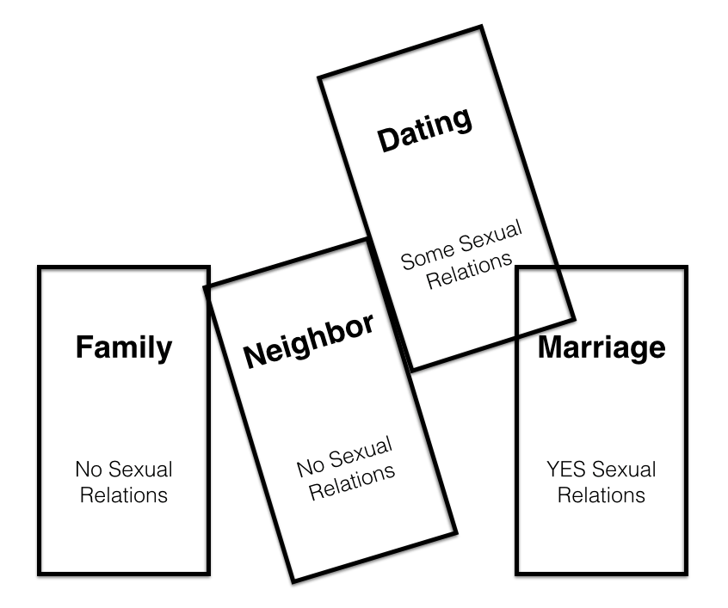
How did people date in the first-century?

- What is the problem with modern dating?

- Why is modern dating bad for women?

- How can I get to know someone of the opposite sex?
  - Pursue dating friendships.
  - Keep the sexual and romantic boundaries of a neighbor relationship.
I adjure you, O daughters of Jerusalem, by the gazelles or the does of the field, that you not stir up or awaken love until it pleases. Song of Solomon 2:7 (ESV)
    - Get accountability.
    - Avoid alone time.
    - Keep an outward focus.
    - Don’t begin a dating friendship when it can’t go anywhere.
    - Keep a dating friendship short.
    - Make a straight line to the altar.
  - Be clear on your boundaries and intent.
God gave us sex and marriage to image the purity and passion of Christ for his bride, the church.

