The New Heavens And Earth

September 3, 2017

Creation Past → Creation Present → New Creation Future

The New Heaven And Earth
Then I saw a new heaven and a new earth, for the first heaven and the first earth had passed away, and the sea was no more. And I saw the holy city, new Jerusalem, coming down out of heaven from God, prepared as a bride adorned for her husband. And I heard a loud voice from the throne saying, “Behold, the dwelling place of God is with man. He will dwell with them, and they will be his people, and God himself will be with them as their God. He will wipe away every tear from their eyes, and death shall be no more, neither shall there be mourning, nor crying, nor pain anymore, for the former things have passed away.” And he who was seated on the throne said, “Behold, I am making all things new.” Also he said, “Write this down, for these words are trustworthy and true.” Revelation 21:1–5 (ESV)
  - The earth can not be our final home because it is under the curse of sin.
And to Adam he said, “Because you have listened to the voice of your wife and have eaten of the tree of which I commanded you, ‘You shall not eat of it,’ cursed is the ground because of you; in pain you shall eat of it all the days of your life; Genesis 3:17 (ESV)
that the creation itself will be set free from its bondage to corruption and obtain the freedom of the glory of the children of God. Romans 8:21 (ESV)
  - The Old Testament talks about the destruction of this creation.
Of old you laid the foundation of the earth, and the heavens are the work of your hands. They will perish, but you will remain; they will all wear out like a garment. You will change them like a robe, and they will pass away, Psalm 102:25–26 (ESV)
Lift up your eyes to the heavens, and look at the earth beneath; for the heavens vanish like smoke, the earth will wear out like a garment, and they who dwell in it will die in like manner; but my salvation will be forever, and my righteousness will never be dismayed. Isaiah 51:6 (ESV)
  - Jesus talked about the destruction of this creation.
Heaven and earth will pass away, but my words will not pass away. Matthew 24:35 (ESV)
  - The Apostle Peter talked about the destruction of this creation.
But by the same word the heavens and earth that now exist are stored up for fire, being kept until the day of judgment and destruction of the ungodly. But do not overlook this one fact, beloved, that with the Lord one day is as a thousand years, and a thousand years as one day. The Lord is not slow to fulfill his promise as some count slowness, but is patient toward you, not wishing that any should perish, but that all should reach repentance. But the day of the Lord will come like a thief, and then the heavens will pass away with a roar, and the heavenly bodies will be burned up and dissolved, and the earth and the works that are done on it will be exposed. Since all these things are thus to be dissolved, what sort of people ought you to be in lives of holiness and godliness, waiting for and hastening the coming of the day of God, because of which the heavens will be set on fire and dissolved, and the heavenly bodies will melt as they burn! But according to his promise we are waiting for new heavens and a new earth in which righteousness dwells. 2 Peter 3:7–13 (ESV)
  - If God is forced to destroy the universe because of sin, Satan won a tremendous victory.
  - If God can resurrect our bodies free from sin, he can resurrect the universe free from sin.
whom heaven must receive until the time for restoring all the things about which God spoke by the mouth of his holy prophets long ago. Acts 3:21 (ESV)
For they deliberately overlook this fact, that the heavens existed long ago, and the earth was formed out of water and through water by the word of God, and that by means of these the world that then existed was deluged with water and perished. But by the same word the heavens and earth that now exist are stored up for fire, being kept until the day of judgment and destruction of the ungodly. 2 Peter 3:5–7 (ESV)
  - “New” means in line with the old but vastly improved.

The New Jerusalem
Then came one of the seven angels who had the seven bowls full of the seven last plagues and spoke to me, saying, “Come, I will show you the Bride, the wife of the Lamb.” And he carried me away in the Spirit to a great, high mountain, and showed me the holy city Jerusalem coming down out of heaven from God, having the glory of God, its radiance like a most rare jewel, like a jasper, clear as crystal. It had a great, high wall, with twelve gates, and at the gates twelve angels, and on the gates the names of the twelve tribes of the sons of Israel were inscribed— on the east three gates, on the north three gates, on the south three gates, and on the west three gates. And the wall of the city had twelve foundations, and on them were the twelve names of the twelve apostles of the Lamb. And the one who spoke with me had a measuring rod of gold to measure the city and its gates and walls. The city lies foursquare, its length the same as its width. And he measured the city with his rod, 12,000 stadia. Its length and width and height are equal. He also measured its wall, 144 cubits by human measurement, which is also an angel’s measurement. The wall was built of jasper, while the city was pure gold, like clear glass. The foundations of the wall of the city were adorned with every kind of jewel. The first was jasper, the second sapphire, the third agate, the fourth emerald, the fifth onyx, the sixth carnelian, the seventh chrysolite, the eighth beryl, the ninth topaz, the tenth chrysoprase, the eleventh jacinth, the twelfth amethyst. And the twelve gates were twelve pearls, each of the gates made of a single pearl, and the street of the city was pure gold, like transparent glass. And I saw no temple in the city, for its temple is the Lord God the Almighty and the Lamb. And the city has no need of sun or moon to shine on it, for the glory of God gives it light, and its lamp is the Lamb. By its light will the nations walk, and the kings of the earth will bring their glory into it, and its gates will never be shut by day—and there will be no night there. They will bring into it the glory and the honor of the nations. But nothing unclean will ever enter it, nor anyone who does what is detestable or false, but only those who are written in the Lamb’s book of life. Revelation 21:9–27 (ESV)
  - Jesus is preparing an amazing place for us in the New Jerusalem.
In my Father’s house are many rooms. If it were not so, would I have told you that I go to prepare a place for you? And if I go and prepare a place for you, I will come again and will take you to myself, that where I am you may be also. John 14:2–3 (ESV)
But, as it is written, “What no eye has seen, nor ear heard, nor the heart of man imagined, what God has prepared for those who love him”— 1 Corinthians 2:9 (ESV)
  - The city is described as having staggering size and beauty.
  - The center of the city is the throne of God, the river of life and the tree of life.
Then the angel showed me the river of the water of life, bright as crystal, flowing from the throne of God and of the Lamb through the middle of the street of the city; also, on either side of the river, the tree of life with its twelve kinds of fruit, yielding its fruit each month. The leaves of the tree were for the healing of the nations. No longer will there be anything accursed, but the throne of God and of the Lamb will be in it, and his servants will worship him. They will see his face, and his name will be on their foreheads. And night will be no more. They will need no light of lamp or sun, for the Lord God will be their light, and they will reign forever and ever. Revelation 22:1–5 (ESV)
  - We will see God’s face!
…They will see his face…
who alone has immortality, who dwells in unapproachable light, whom no one has ever seen or can see. To him be honor and eternal dominion. Amen. 1 Timothy 6:16 (ESV)
You make known to me the path of life; in your presence there is fullness of joy; at your right hand are pleasures forevermore. Psalm 16:11 (ESV)
Application
  - The new creation will be this creation purified, resurrected and vastly improved. Let
  - the God-glorifying pleasures of this life whet your appetite for the same but vastly improved pleasures when this earth is resurrected and combined with heaven for eternity.
  - Look forward to living in a city—not the country—and loving it.
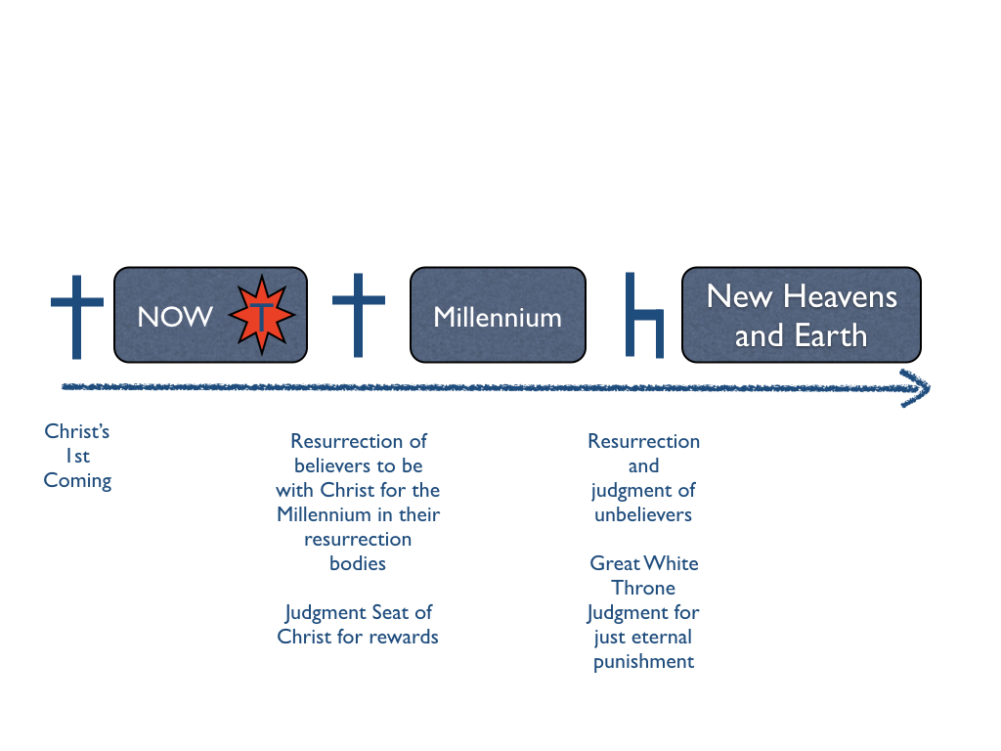
  - Look forward to the thrill of seeing the face of God, which is the source of all joy and never-ending pleasure.
