Mark 13:1–23 — Jesus And The Destruction of Jerusalem
August 30, 2020

- Jesus left Jerusalem and predicted its destruction. — v.1-4.

And as he came out of the temple, one of his disciples said to him, “Look, Teacher, what wonderful stones and what wonderful buildings!” Mark 13:1 (ESV)

And Jesus said to him, “Do you see these great buildings? There will not be left here one stone upon another that will not be thrown down.” Mark 13:2 (ESV)

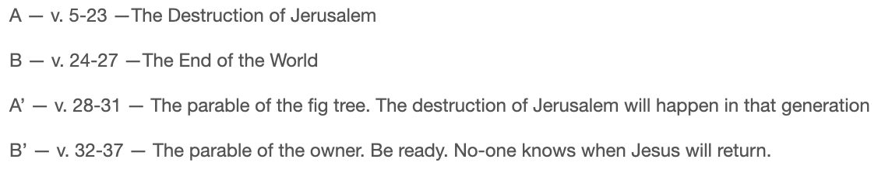
And as he sat on the Mount of Olives opposite the temple, Peter and James and John and Andrew asked him privately, “Tell us, when will these things be, and what will be the sign when all these things are about to be accomplished?”
Mark 13:3–4 (ESV)

As he sat on the Mount of Olives, the disciples came to him privately, saying, “Tell us, when will these things be, and what will be the sign of your coming and of the end of the age?” Matthew 24:3 (ESV)

- What were the false signs of Jerusalem's destruction? — v.5-8
  - There will be false messiahs who will speak lies.
And Jesus began to say to them, “See that no one leads you astray. Many will come in my name, saying, ‘I am he!’ and they will lead many astray.
Mark 13:5–6 (ESV)

  - There will be human disasters, such as wars.
And when you hear of wars and rumors of wars, do not be alarmed. This must take place, but the end is not yet. Mark 13:7 (ESV)

  - There will be natural disasters, such as earthquakes.
For nation will rise against nation, and kingdom against kingdom. There will be earthquakes in various places; there will be famines. These are but the beginning of the birth pains. Mark 13:8 (ESV)

- What should Christians expect before Jerusalem’s destruction? — v.9-13
  - Expect to be persecuted and taken to court.
But be on your guard. For they will deliver you over to councils, and you will be beaten in synagogues, and you will stand before governors and kings for my sake, to bear witness before them. Mark 13:9 (ESV)

  - Expect the gospel will be proclaimed to all nations.
And the gospel must first be proclaimed to all nations. Mark 13:10 (ESV)

  - Expect the Holy Spirit will provide wisdom on what to say when brought to court.
And when they bring you to trial and deliver you over, do not be anxious beforehand what you are to say, but say whatever is given you in that hour, for it is not you who speak, but the Holy Spirit. Mark 13:11 (ESV)

  - Expect to be betrayed, even by their own family.
And brother will deliver brother over to death, and the father his child, and children will rise against parents and have them put to death. Mark 13:12 (ESV)

  - Expect to be hated for Christ, but enduring to the end means we will be saved by Christ.
And you will be hated by all for my name’s sake. But the one who endures to the end will be saved. Mark 13:13 (ESV)

They went out from us, but they were not of us; for if they had been of us, they would have continued with us. But they went out, that it might become plain that they all are not of us. 1 John 2:19 (ESV)

- The abomination of desolation is the true sign of Jerusalem’s destruction. — v.14-23

But when you see the abomination of desolation standing where he ought not to be (let the reader understand), then let those who are in Judea flee to the mountains. Mark 13:14 (ESV)

But when you see Jerusalem surrounded by armies, then know that its desolation has come near. Luke 21:20 (ESV)

Let the one who is on the housetop not go down, nor enter his house, to take anything out, and let the one who is in the field not turn back to take his cloak. And alas for women who are pregnant and for those who are nursing infants in those days! Pray that it may not happen in winter. Mark 13:15–18 (ESV)

For in those days there will be such tribulation as has not been from the beginning of the creation that God created until now, and never will be. And if the Lord had not cut short the days, no human being would be saved. But for the sake of the elect, whom he chose, he shortened the days. Mark 13:19–20 (ESV)

“Indeed, in my opinion, the misfortunes of all nations since the world began fall short of those of the Jews.” - Josephus, Jewish Wars, 1.12

They will fall by the edge of the sword and be led captive among all nations, and Jerusalem will be trampled underfoot by the Gentiles, until the times of the Gentiles are fulfilled. Luke 21:24 (ESV)

And then if anyone says to you, ‘Look, here is the Christ!’ or ‘Look, there he is!’ do not believe it. For false christs and false prophets will arise and perform signs and wonders, to lead astray, if possible, the elect. Mark 13:21–22 (ESV)

But be on guard; I have told you all things beforehand. Mark 13:23 (ESV)

- Application
  - Don’t be deceived by false teachers.

  - Be careful of end-time speculation.

  - God is in complete control, even when the world feels out of control.

  - Christians will face suffering, but God will use it for the spread of the gospel.

Life Group Questions
- Why did the Jews think the temple could not be destroyed? Do we feel the same way about different buildings and institutions in our society? What is the danger in trust in the permanence of those things?
- What do you find discouraging about Jesus prophecy concerning the destruction of Jerusalem? What is encouraging?
- How can persecution of Christians lead to the spread of the gospel? Can you think of any recent examples?
- In what context should you, “Not worry beforehand what you will say?” Does this mean we should not study and prepare before we talk about Jesus?
- Death is a possible result of persecution. What should be our attitude toward death? Why is this difficult to take to heart?
- What in these verses teach us God is in control of everything in this world, even tragedy? How is that encouraging?

