Mark 13:24–37 — Jesus And The End Of The World
September 6, 2020

As he sat on the Mount of Olives, the disciples came to him privately, saying, “Tell us, when will these things be, and what will be the sign of your coming and of the end of the age? Matthew 24:3 (ESV)

- What were the signs of Jerusalem’s impending destruction? — v.5-23
  - There will be false signs of the end, such as earthquakes, famines, and wars.

  - Persecution is a false sign. If they persecuted Jesus, they will persecute me.

  - The abomination of desolation and armies surrounding Jerusalem were the true signs of Jerusalem’s destruction.

- What will be the signs of Jesus’ coming and the end of the world? — v.24-27
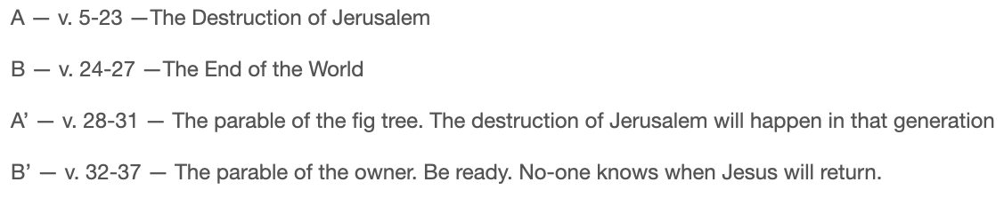
  - There are grammatical clues Jesus has changed to this question.

They will fall by the edge of the sword and be led captive among all nations, and Jerusalem will be trampled underfoot by the Gentiles, until the times of the Gentiles are fulfilled. Luke 21:24 (ESV)

And as he sat on the Mount of Olives opposite the temple, Peter and James and John and Andrew asked him privately, “Tell us, when will these things be, and what will be the sign when all these things are about to be accomplished?” Mark 13:3–4 (ESV)

Truly, I say to you, this generation will not pass away until all these things take place. Heaven and earth will pass away, but my words will not pass away. “But concerning that day or that hour, no one knows, not even the angels in heaven, nor the Son, but only the Father. Mark 13:30–32 (ESV)

  - When Jesus returns, the sun and moon will dim.
“But in those days, after that tribulation, the sun will be darkened, and the moon will not give its light… Mark 13:24 (ESV)

When he opened the sixth seal, I looked, and behold, there was a great earthquake, and the sun became black as sackcloth, the full moon became like blood, Revelation 6:12 (ESV)

  - When Jesus returns, the stars will fall from heaven and the planets will shake.
and the stars will be falling from heaven, and the powers in the heavens will be shaken. Mark 13:25 (ESV)

and the stars of the sky fell to the earth as the fig tree sheds its winter fruit when shaken by a gale. The sky vanished like a scroll that is being rolled up, and every mountain and island was removed from its place.
Revelation 6:13–14 (ESV)

Behold, the day of the LORD comes, cruel, with wrath and fierce anger, to make the land a desolation and to destroy its sinners from it. For the stars of the heavens and their constellations will not give their light; the sun will be dark at its rising, and the moon will not shed its light. Isaiah 13:9–10 (ESV)

  - When Jesus returns, it will be in the clouds with great power and glory.
And then they will see the Son of Man coming in clouds with great power and glory. Mark 13:26 (ESV)

I saw in the night visions, and behold, with the clouds of heaven there came one like a son of man, and he came to the Ancient of Days and was presented before him. And to him was given dominion and glory and a kingdom, that all peoples, nations, and languages should serve him; his dominion is an everlasting dominion, which shall not pass away, and his kingdom one that shall not be destroyed. Daniel 7:13–14 (ESV)

  - When Jesus returns, he will come to save us.
And then he will send out the angels and gather his elect from the four winds, from the ends of the earth to the ends of heaven. Mark 13:27 (ESV)

- When will the destruction of Jerusalem take place? — v.28-31
From the fig tree learn its lesson: as soon as its branch becomes tender and puts out its leaves, you know that summer is near. Mark 13:28 (ESV)

So also, when you see these things taking place, you know that he is near, at the very gates. Mark 13:29 (ESV)

Truly, I say to you, this generation will not pass away until all these things take place. Mark 13:30 (ESV)

  - Jesus’ words have more permanence than the Old Testament.
Heaven and earth will pass away, but my words will not pass away.
Mark 13:31 (ESV)

For truly, I say to you, until heaven and earth pass away, not an iota, not a dot, will pass from the Law until all is accomplished. Matthew 5:18 (ESV)

- When will the world end and Christ return? — v.32-37

But concerning that day or that hour, no one knows, not even the angels in heaven, nor the Son, but only the Father. Mark 13:32 (ESV)

Be on guard, keep awake. For you do not know when the time will come.
Mark 13:33 (ESV)

It is like a man going on a journey, when he leaves home and puts his servants in charge, each with his work, and commands the doorkeeper to stay awake. Therefore stay awake—for you do not know when the master of the house will come, in the evening, or at midnight, or when the rooster crows, or in the morning— lest he come suddenly and find you asleep. And what I say to you I say to all: Stay awake. Mark 13:34–37 (ESV)

- Application
  - Nothing in the Olivet Discourse indicates Jesus was talking about a future rapture followed by a 7-year period of tribulation.

  - Be careful about speculating when Christ will return.

  - Live as if Jesus will return TODAY!

Life Group Questions
- How does a failed prediction of Jesus’ return harm the church? How does the false belief that Jesus will never return harm the church?
- What is the significance of the upheaval of sun, stars and heavenly bodies right before Jesus arrives?
- Since Jesus could return at any time, how does that change the way we deal with broken relationships? Our daily work? The way we treat people? How we handle money?
- What would you say to those who think we shouldn’t worry about living for Jesus’ return because he hasn’t returned in the last 2,000 years?
- How would you respond to someone who claims to know the date of Christ’s return?
- What would you say to someone that claimed Jesus could not come soon because certain events must happen in world history before he comes?

