Mark 14:1–11 — Jesus And Radical Love
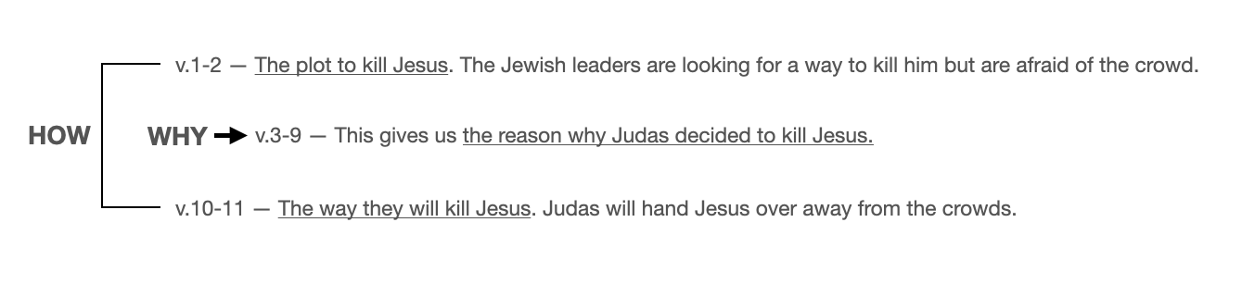
September 13, 2020

- The Sanhedrin plotted to kill Jesus. — v. 1-2
It was now two days before the Passover and the Feast of Unleavened Bread. And the chief priests and the scribes were seeking how to arrest him by stealth and kill him, for they said, “Not during the feast, lest there be an uproar from the people.” Mark 14:1–2 (ESV)

- It was an act of extravagant love that led to the betrayal of Jesus. — v.3-9
And while he was at Bethany in the house of Simon the leper, as he was reclining at table,… Mark 14:3 (ESV)

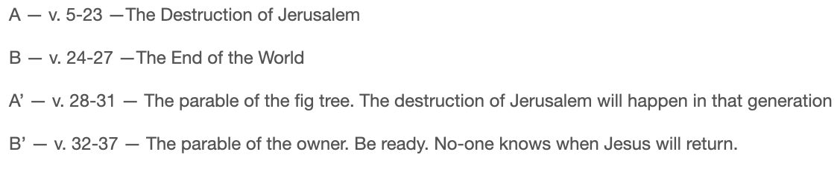
Six days before the Passover, Jesus therefore came to Bethany, where Lazarus was, whom Jesus had raised from the dead. So they gave a dinner for him there. Martha served, and Lazarus was one of those reclining with him at table. John 12:1–2 (ESV)

…a woman came with an alabaster flask of ointment of pure nard, very costly, and she broke the flask and poured it over his head. Mark 14:3 (ESV)

Mary therefore took a pound of expensive ointment made from pure nard, and anointed the feet of Jesus and wiped his feet with her hair. The house was filled with the fragrance of the perfume. John 12:3 (ESV)

When the Jews who were with her in the house, consoling her, saw Mary rise quickly and go out, they followed her, supposing that she was going to the tomb to weep there. Now when Mary came to where Jesus was and saw him, she fell at his feet, saying to him, “Lord, if you had been here, my brother would not have died. John 11:31–32 (ESV)

Jesus said, “Take away the stone.” Martha, the sister of the dead man, said to him, “Lord, by this time there will be an odor, for he has been dead four days. John 11:39 (ESV)

There were some who said to themselves indignantly, “Why was the ointment wasted like that? For this ointment could have been sold for more than three hundred denarii and given to the poor.” And they scolded her. Mark 14:4–5 (ESV)

But Judas Iscariot, one of his disciples (he who was about to betray him), said, “Why was this ointment not sold for three hundred denarii and given to the poor?” He said this, not because he cared about the poor, but because he was a thief, and having charge of the moneybag he used to help himself to what was put into it. John 12:4–6 (ESV)

There were some who said to themselves indignantly, “Why was the ointment wasted like that? For this ointment could have been sold for more than three hundred denarii and given to the poor.” And they scolded her. Mark 14:4–5 (ESV)

But Jesus said, “Leave her alone. Why do you trouble her? She has done a beautiful thing to me. For you always have the poor with you, and whenever you want, you can do good for them. But you will not always have me. Mark 14:6–7 (ESV)

She has done what she could; she has anointed my body beforehand for burial. And truly, I say to you, wherever the gospel is proclaimed in the whole world, what she has done will be told in memory of her.” Mark 14:8–9 (ESV)

- Judas chose to betray Jesus. — v.10-11
Then Judas Iscariot, who was one of the twelve, went to the chief priests in order to betray him to them. And when they heard it, they were glad and promised to give him money. And he sought an opportunity to betray him. Mark 14:10–11 (ESV)

- Conclusion
- The story on the outside tells us how Jesus will be betrayed. The story on the inside tells us why Jesus will be betrayed. Judas did not think Jesus was worthy of extravagant love.
- The story on the outside tells us how Jesus’ enemies prepared for his death by plotting to kill him. The story on the inside tells us how Mary prepared for his death by an extravagant act of love and gratitude. The perfume lingered on him all the way to the grave.
- The story on the outside tells us how Jesus’ enemies arranged for his death by spending a meager sum of money. The story on the inside tells us how Mary prepared for Jesus’ death by spending an enormous sum of money.
- The story on the outside tell us how Judas and the Jewish leaders acted secretly afraid of the crowds reactions. The story on the inside tells how Mary acted publicly and faced peoples angry reactions

- Application
  - Which character are you in the dining room?
    - Are you Judas who doesn’t think a radical act of love and gratitude for Jesus is appropriate?
    - Are you Mary who thinks an extravagant demonstration of your love for Jesus is the only proper response after all he has done for you?

Life Group Questions
- Read Mark 14:1-11, John 12:1-8, Matthew 26:6-13. How are these accounts similar? What do John and Matthew add that is helpful to know when studying our passage in Mark?
- Kurt gave some ways the inside and outside stories in Mark 14:1-11 relate to one another and contrast one another. Can you think of additional contrasts between them? If not, simply review the contrasts given in the sermon.
- What is the costliest act of sacrifice and devotion you have made out of love for Jesus?
- Judas and others in the room said the value of Mary’s gift exceeded the limit of what should be spent on Jesus. How are we like that today?
- How do you think Mary’s willingness to make such an extravagant act of love for Jesus made Judas, and others in the room, feel? How does that challenge the way we live?
- How should we balance practical, responsible stewardship and radical, extravagant giving? Do you find yourself using responsible living to avoid radical living? What are we missing when we do that?
- Judas was someone who tried to profit from Christ. Mary was someone who out of gratitude wanted to give extravagantly to Christ. In what ways do people try to profit from Jesus today? How do people try to profit from Christ’s church instead of being grateful givers serving Christ in His church?

